LAB 2: Basics of ROS II
By: Vy Tang
ID: 77659006

Objective

Problem 1: SwimNode
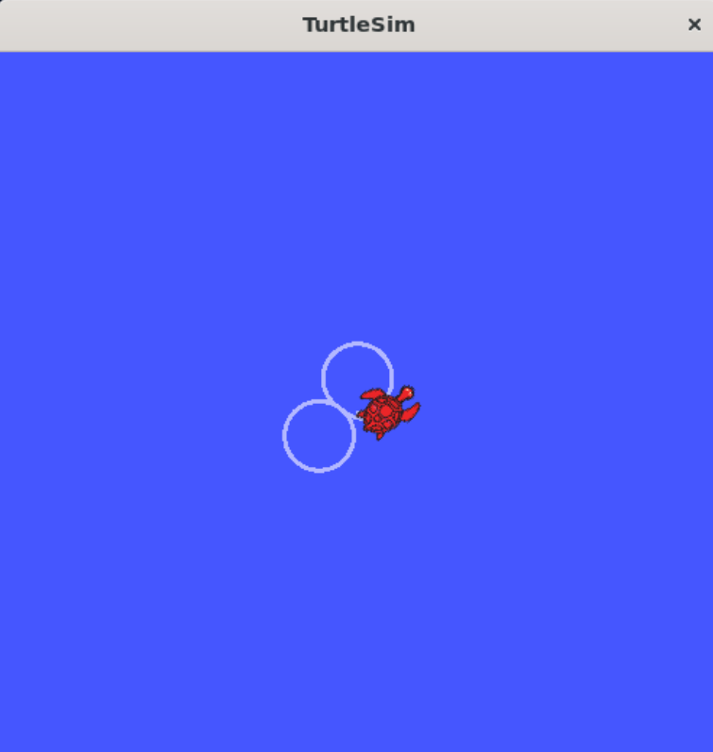
Code Explanation and Breakdown
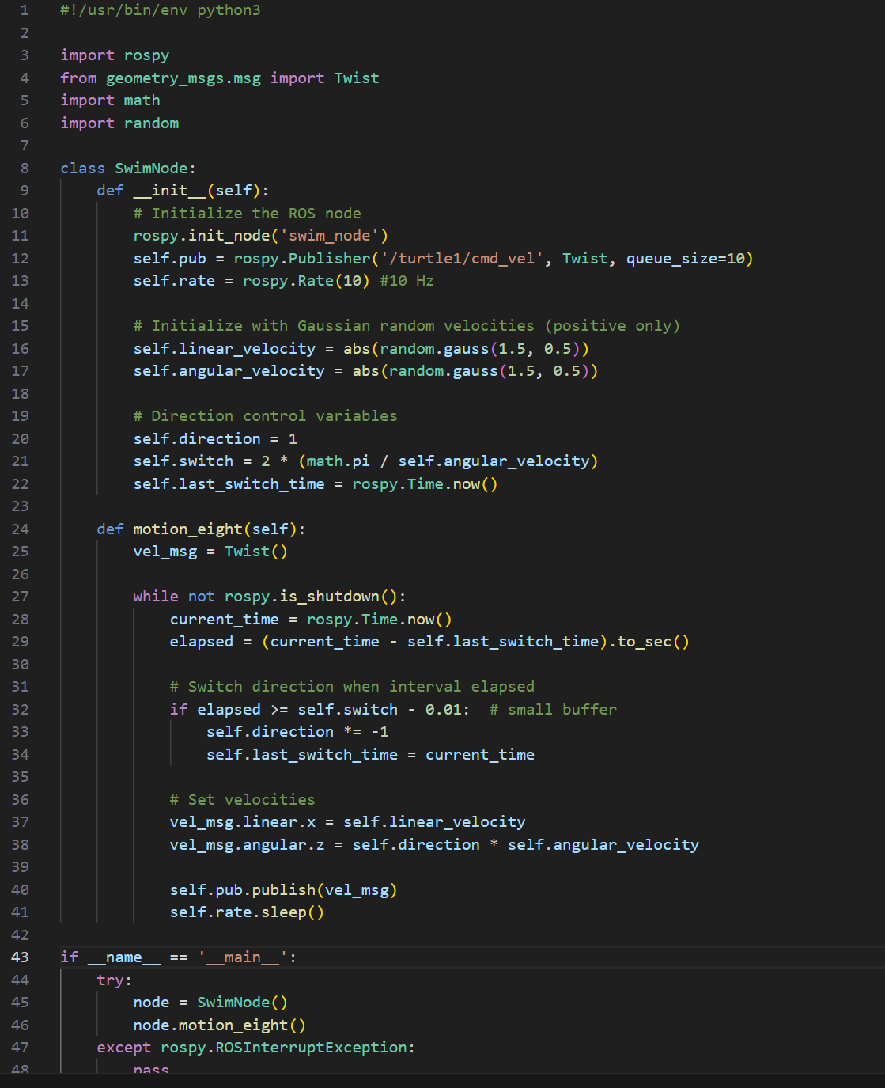
For the first problem, I created a class and initialized the nodes using the init.node and .publisher to initialize my nodes and declare the publisher from the rospy library. Then I set a random arbitrary value using the random library and set the forward and turning speed.
Next, is the direction control setup. Here, the direction is initially set to 1 which is positive for left turns and it will alternate between 1 and -1 for left and right turns. The switch method is to indicate the period in which the turtle will switch and for this, we will use the math library to get the pi value as the period is T = 2pi/w where w is the angular velocity set previously. After that, keep track of the last time there was a change in direction using the .time method.
For the function responsible for creating the figure 8, the Twist message for velocity commands is called and inside the while loops which keeps running until ROS shuts down, it tracks the elapsed time since the last direction change. Then, an if statement will check if the elapsed time is greater than the switch interval (period) and if it does, flip the direction and update the last switched time to the current time. After that, I set the constant forward speed and the turning speed in the twist message and publishes the velocity command to the turtle. The final code block with an if-statement is for when the program ends to stop the curses function. It will also check if there is any launch failures.
The final code block handles main execution and creates node instance and starts motion as well as handling interruption cases.

Problem 2: SwimtoNode
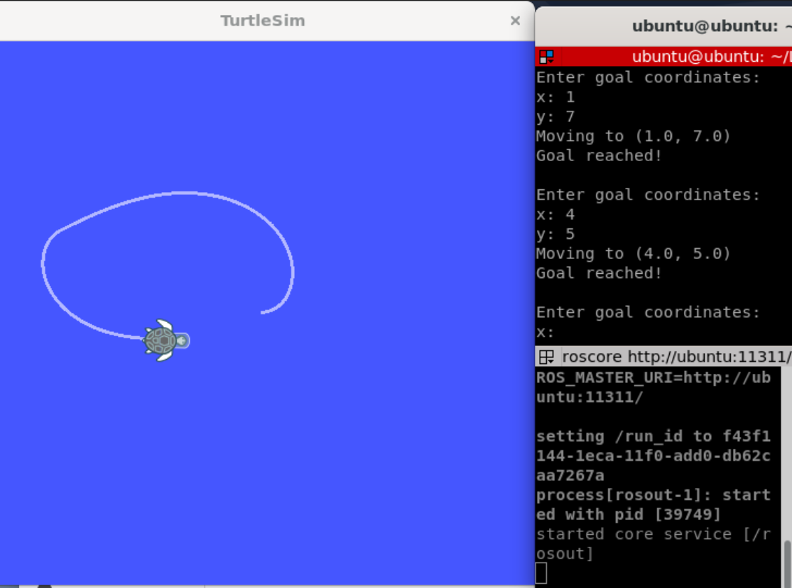

Code Explanation and Breakdown
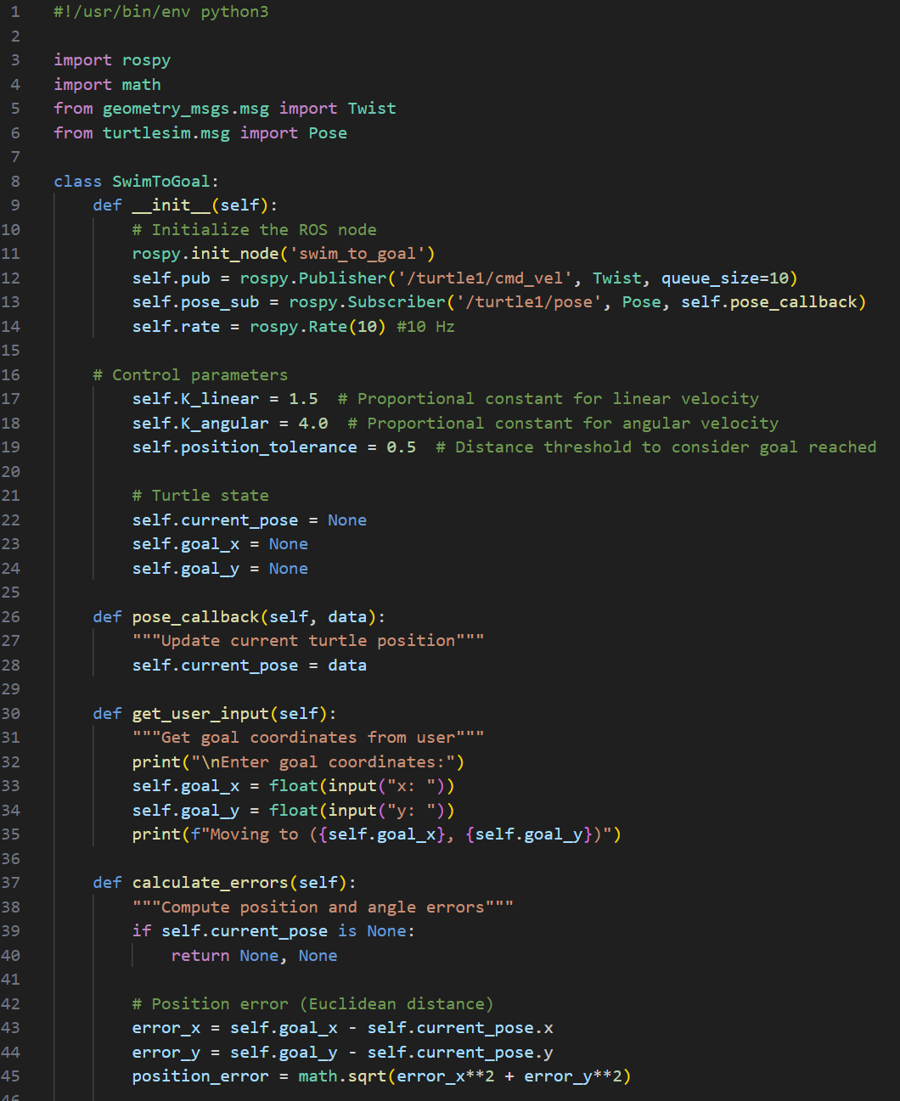
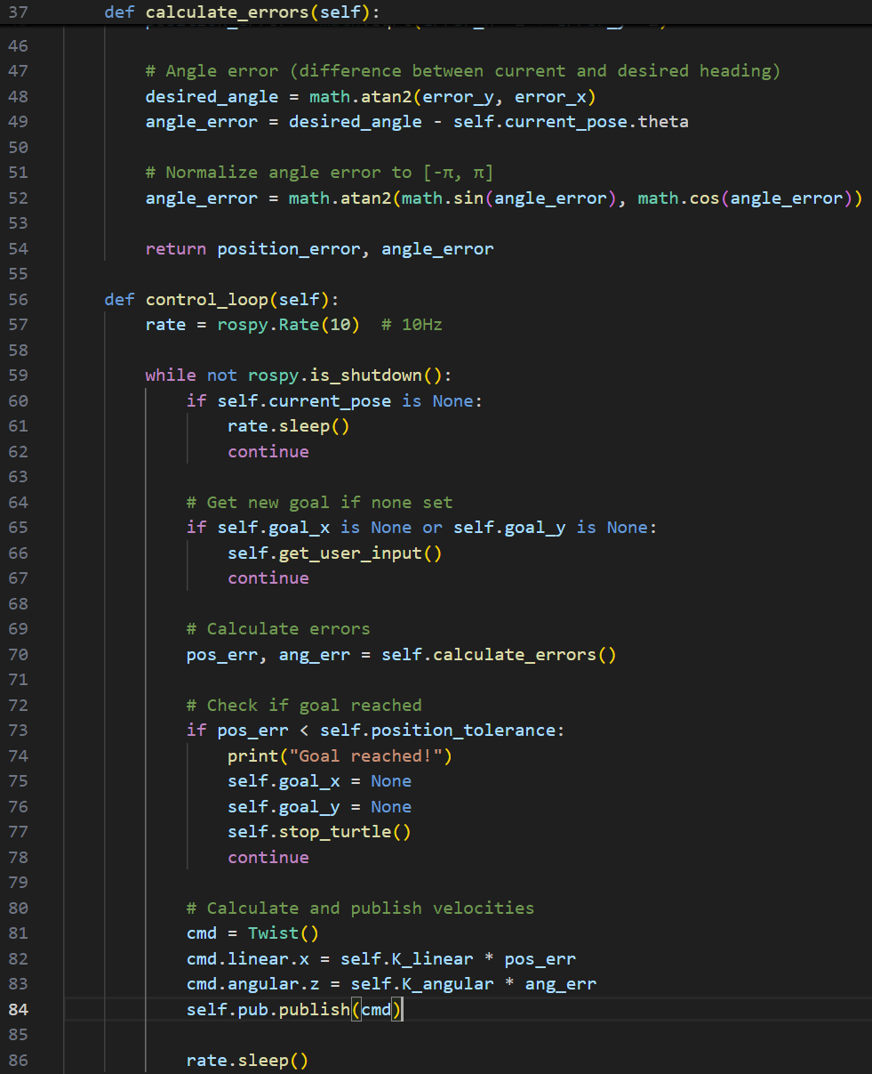
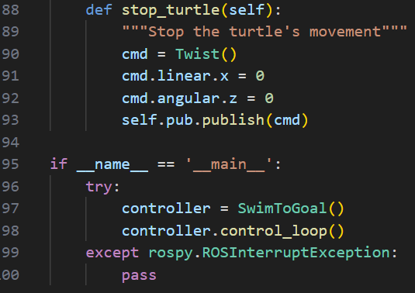

The approach to initialize the publisher is still relatively the same except this time, there will be a subscriber to the publisher turtle1 which serves to read the turtle’s current pose. To further initialize the node, I set the proportional gains for velocity control and the position tolerance of how close the turtle must get to its goal which is 0.5 units. Also, the turtle state is also defined to be in origin.
Next, I defined several function methods to help me with calculation. First, I created a pose_callback method to update the current pose whenever the new pose data arrives. There is also a get_user_input method to prompt the user for x and y coordinates of where the user wants the turtle to end up i.e. the goal_x, goal_y. The calculate_errors method computes the Euclidian distance to the goal (i.e. the position error) as well as calculating the angle difference between the current heading and goal direction. Finally, to normalize the angle error, I used the math.atan method call to normalize the angle error to [-pi, pi].
After defining my necessary methods, I will finally implement the control loop function which is the core logic of the swim_to_goal node. First, there is a while loop that continuously loops and keeps running until ROS is shutdown. In the first two if-statements, the first one will check if there is pose data yet and if there isn’t, it will delay the execution of the program until there is a pose data. The second if-statement will check if there is a goal yet and if there isn’t it will set a new goal for the turtle. Then, we will actually call the calculate_errors method defined earlier to then check if the turtle as reached the goal within the tolerance distance (i.e. 0.5 as mentioned in the beginning). The turtle will then stop and the goals of the turtle will be reset once the turtle reaches its goal. Finally, there is the stop_turtle method which publishes a zero-velocity command to halt the turtle.
The final code block handles main execution and creates node instance and starts motion as well as handling interruption cases.

